5.5 Surface Integrals

Motivation:
In section 5.2.1 we discussed the idea that a line integral was useful for adding up a quantity over a given curve C. In this section we wish to extend this idea to adding up a quantity over a given surface to create the idea of a surface integral.

This idea can be useful in a variety of applications
- Adding up charge across a magnetized surface.
- Adding up gravitational forces across a surface.
- Adding up the density across a surface to help find the mass of the surface.
- Adding up flow of fluid through to help find the total quantity of fluid flowing through .

So, how do we construct an integral that will do this?

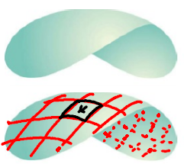
Exploration: Suppose we have a smooth surface that we plan to move across, and we want to add up the quantity at each point given by the function . Let Q represent the total quantity over the surface. How do we find Q?

We can begin by partition up into n patches.

Consider the k^{th} patch and choose a representative point for this patch.

If we let represent the surface area of this patch and represent the quantity that exists over this patch. If we measure function f at we obtain an approximation of the quantity we are adding up over this patch to be

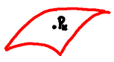
Therefore, and as n approaches infinity we suspect the approximation to approach the correct value.

Therefore, we have

This leads us to the following definition.
Definition: Assuming that is continuous, the surface integral of f over the surface is .

Remark: Let be the parameterization of the surface . We saw in section 4.4 that the surface area of the k^{th} patch, , is approximated by .

Therefore, we can rewrite the previous definition as follows.
Definition (Updated): Assuming that is continuous, the surface integral of f over the surface is
.

Remark: Note that if , then the surface integral becomes which we know from section 4.4 yields the surface area of .

Example 1: Consider the surface .

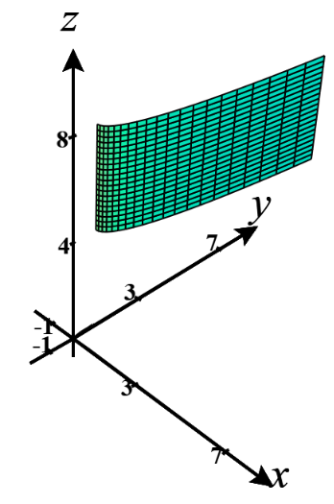
- Find a parameterization for .

A parameterization for is .

- Evaluate .
We note that Then, , and we have that

Example 2: Compute the surface integral where is the unit sphere
Hint: Use what you know about spherical coordinates to find parametric equations for .
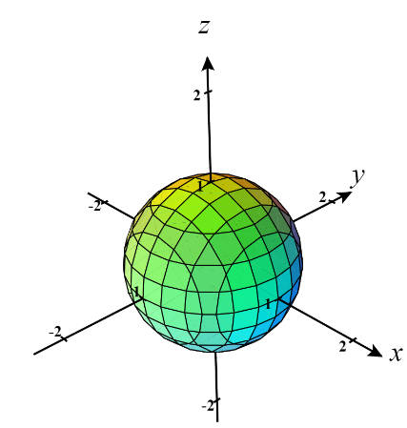
Parametric equations for are: .
If we replace with u and with v we can parameterize the surface as
.

Note that you don’t have to replace with u and with v and then get.

In order to set up the surface integral as an iterated integral we need to know . So, we calculate that
Then,

Since we know that , we have that .

Now, we have that . If we let , then we note that , , and . This means

Example 3: Suppose is a smooth surface given by where . Express the surface integral as a double integral in terms of x and y.

Using a technique from section 4.4, we know that a parameterization for is: where u and v satisfy the same conditions as x and y. We can therefore rewrite this parameterization as: . By definition we know that .

We now have written the surface integral as a double integral in terms of x and y, but we will simplify the double integral a bit further. Note that and . This implies that and .
So,

Note: In this example we are assuming that f is continuous on . Oftentimes this condition is just assumed without being stated in the textbook.

The most recent example is the justification for the following formulas.

Formulas: Suppose is a smooth surface given by where . Then,
- A normal vector to the surface at is .

Note: It is possible to derive similar formulas in the cases where the surface is given by or when the surface is given by . Can you guess what the formulas would be in these cases? See page 1133 of the book for one of the formulas.
Example 4: Fully setup, but do not evaluate, the surface integral where is the portion of the surface which exists over the triangular region with endpoints .

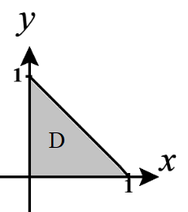
We first note that the region D has the following picture and can be defined as know that

We now state a fact which we will recognize as an extension of a property of line integrals.

Fact: If is a finite union of smooth surfaces: (we say is piecewise-smooth), then

.

Example 5: Suppose that is the “can without a top” which consists of and .

- Find a parameterization of .
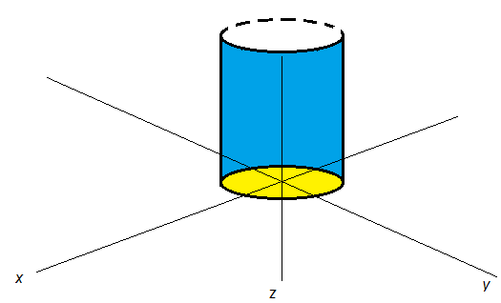
First, a picture of the surface with in blue and in yellow is:

Using the idea of cylindrical coordinates an answer is: where and .

- Find a parameterization of .

Using the idea of polar coordinates, an answer is: where and .

- Evaluate .

Using the most recent fact, we have that:
So, we calculate: and .

We are now able to calculate the answer:

- Note that didn’t need to be parameterized and could have just been expressed as the surface in the form of over a region D. Find the surface integral for using this approach.

We see that if is written as over a region D, the we define .

Therefore,

